Scaling is one of is one of the most inevitable phenomenon in aluminium producing refineries that impedes production and causes significant downtime of the process in terms of cleaning pipes and other involved machinery. This often involves 3%-5% of overall production costs which is significant in numbers.So it’s needless to say how important it is to monitor and remove scaling effectively to get the optimum production from aluminium plant.Currently there are different physical methods for detecting amount of scaling inside pipelines. Even some of which can measure scaling in-situ mode (Operations need not to be brought down ). Approximate cost involved and few other details are mentioned in this table below.  
  
  
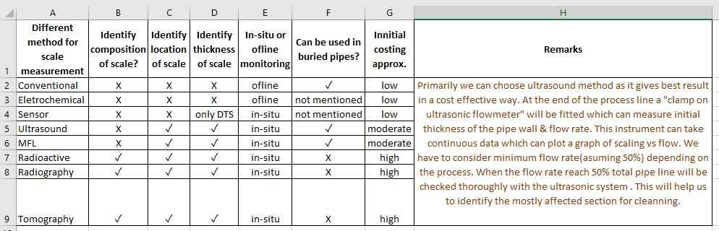

***Table 1***  
  
Most of the in-situ processes provide significant results in terms of identifying location of scaling and thickness of the scale, but also involves moderate to high costs in the process of identifying the scaling in the pipe.  
So, basically there are 3 types of costs incurred due to scaling problem.  
  
1.Reduction in production.  
2.Scaling location and thickness identification cost.  
3.Production downtime due to de-scaling.

**Idea for this ideathon:**To reduce these costs mentioned above, cutting edge digital technologies can play a significant role. So, here is the idea on how a deep neural network can be used to predict scaling thickness at any time, almost at zero cost with more than 85-90% of accuracy. Although DNNs are mostly known for classification problems, but here we will try to ideate a model that will give output as a continuous variable like regression problems. To be honest, with proper usage of parameters and hyper-parameters deep neural network can even outperform popular random forest and XGBoost methods.  
Here is a sample dataset that can be used as training and validation data (70-30 ratio) to train and test accuracy of the NN model.  
  
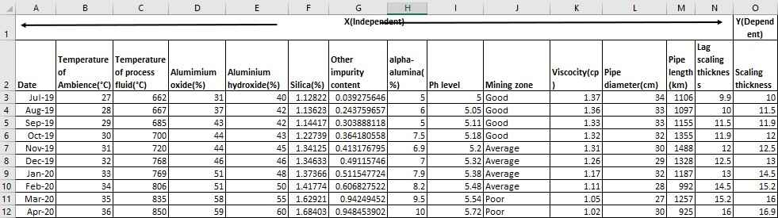

***Table 2***

***Please Note: These are just dummy data, prepared by me for this ideathon to give a flavor of how the proposed model may work. Actual data may vary and subjected to be verified by industry experts. Also, deep neural network needs much larger training dateset to give higher level of accuracy***

*.*  
**A brief introduction of the independent parameters:  
  
  
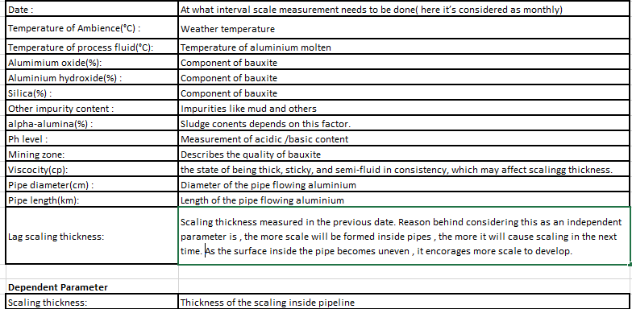  
*Table 3***

***Deep Neural Network model with ReLu (Rectified linear Unit )as activation function:  
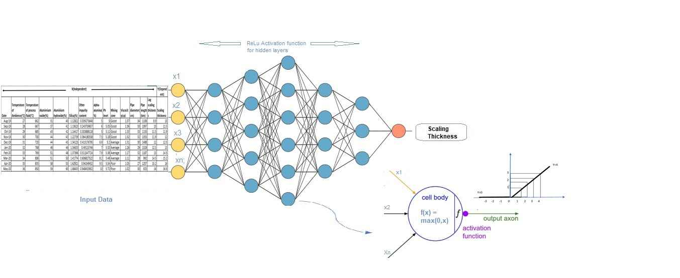***

**Details of DNN model :**

1.First need to check correlation between independent and dependent variables to identify most significant inputs. Once identified, we need to feed only those independent variables into DNN.

2.Need to define a sequential model.  
3.Add some dense layers.  
4.Use**ReLu or Leaky ReLu** as the activation function for the hidden layers.  
5.Use a ‘**normal**’ initializer as the kernal_intializer. (Initializers define the way to set the initial random weights of Keras layers.)  
6.Mean_absolute_error can be used as loss function.  
7.There will be only one output node which will predict scaling thickness.  
8.Load hyperparameters and weights.  
9.Fit training data into above specified DNN.  
10.Predict validation data to check accuracy.  
11.Feed new independent parameters to calculate future scaling thickness.

Please Note, before building this model, it is necessary to collect scaling thickness data by any of the physical measurement methods as mentioned in the ***Table 1***. Once we get enough data to prepare ***Table 2*** to train and validate the model , then the model can be run with different input parameters (test data) to check how much scaling can accumulated in the pipeline.  
For example, if below mentioned is the future data for the month of May to know how much scaling may accumulate in the next month, the above mentioned DNN can predict it easily.

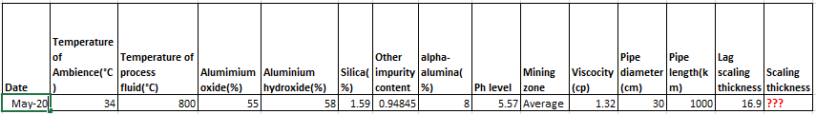

***Table 4***  
Now, if somehow there is a reduction in production of aluminium and this neural network model is not showing any significant amount of scaling thickness, then industry experts can probe for other issues and can easily skip the cost of measuring the scale physically (mentioned in ***Table1***).  
Otherwise, if the model predicts good amount of scaling thickness, then experts may decide to check physically or directly go for descaling based on business decisions taken.  
  
**Benefit of this model:**

1.Can measure scaling thickness without physical intervention as many times it's required.  
2.Able to notify about production reduction due to scaling well ahead of time.  
3.Can skip / reduce physical scaling measurement processes.  
4.Business experts can plan production downtime well ahead of time.  
5.Only one-time model building cost is involved, no cost of scaling measurement on a regular interval.

***Please Note: Model building may take 6-8 months of time, python can be used as coding language, FTE =3(including 1 domain knowledge expert) , cost involved may vary from $1000- $2000.***